Charlie Nitschelm  
ME 646  
3/3/2019

Lab 3

# Part 1 – Beam/Strain Gauge Response

## 1a)

Figure 1 - Beam and strain gauge setup using a wheatstone bridge to pull in the voltage, an amplifier to increase the readings, and a scope to record the data

Thickness = .05 in in

Wheatstone Bridge

Amplifier

Scope

Strain Gages

-5V

+5V

+15V

-15V

Length = 6.58 in

Width = .497 in in

## 1b)

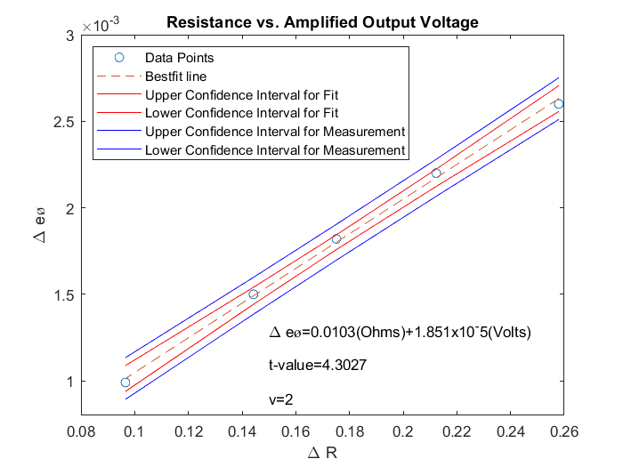

### Solving for ΔR in the Wheatstone Bridge

and

And so reduces to

### Bridge Sensitivity

Using MATLAB, an observed bridge sensitivity of 0.01 V/Ω was calculated from the data. To calculate the expected bridge sensitivy using primarily the wheatstone bridge setup, we must derive the equation using a quarter wheatstone bridge.

Where R2 = R3 = R4 = R and R1 = R + .

And as approaches zero, the equation becomes:

Using this equation, an expected bridge sensitivity of 0.0104 V/Ω was found using an input voltage of 5V and knowing the resistors used were 120 Ω

## 1c)

The equation that relates the strain the beam experiences, the gage factor, the voltage gain input and the input voltage is derived from the half wheatstone bridge by

And with the and and the equation becomes:

## 1d)

The hysteresis for the data was calculated to have a maximum value of 1.21% for the voltage measurement on the beam using different load values increasing then decreasing. The number was determined by calculating the difference between the corresponding loads as it was measured when the load was increasing to when it was decreasing. That difference was then divided by the total voltage difference from no load to the largest load. Please adhere to the table below that displays the data used for this calculation when increasing and decreasing load.